***Extendible Hashing Example***

Key values: 32, 28, 43, 15, 66, 27

Hash Function h(k) = k mod 10

Bucket size: 2

|  |  |  |  |  |  |  |
| --- | --- | --- | --- | --- | --- | --- |
| Key | 32 | 28 | 43 | 15 | 66 | 27 |
| Hash value | 2 | 8 | 3 | 5 | 6 | 7 |
| In Binary | 0010 | 1000 | 0011 | 0101 | 0110 | 0111 |

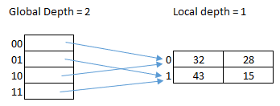

Insert 66

No space in bucket. So expand the by allocating new bucket. Local depth of that bucket becomes 2.

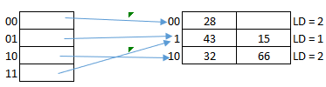

Insert 27

No space in bucket. So expand the by allocating new bucket. Local depth of that bucket becomes 2.

